EXPERIMENT-11

PROCEDURES

Aim:

1. Create a table with attributes students and marks.
2. Insert values into the table.
3. Create a procedure to get the merit students (marks > 50).
4. Create a procedure to get marks of a given id (using in).
5. Create a procedure to display highest marks (using out).
6. Create a procedure to get marks of a given id (using in and out).

1.



2.



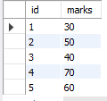

3.

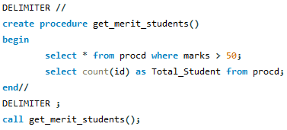



4.

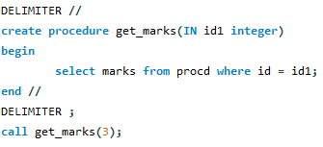



5.

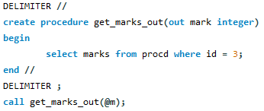



6.

